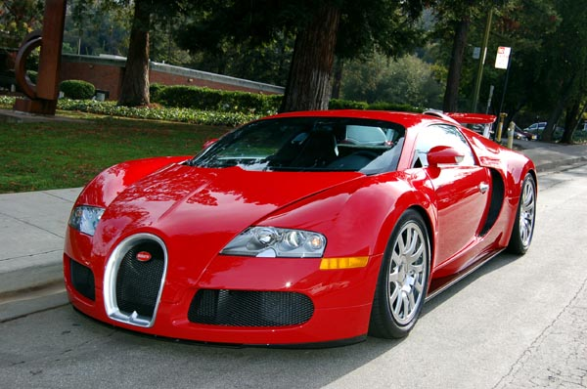

SPOT THE MISTAKES IN THE FOLLOWING TEXT AND CORRECT THEM.

THE WRONG LOVER

A men from London, Mr Harvey, had a very beutiful young wive. He was much older then his wive and he began to think he was in love with a younger men. Four many weeks he thought about his wive and this other men. Every day he went to work and he was more and more unhapy when he thought about them together.
‘What can I do? Am I two old for her? Perhaps she doesn’t love me,’ he thought. He knew that his wive was at home all day. ‘What does she do? Is she hapy? Does she meet other men?’
One day Mr Harvey thought, ‘I’ll go home in the afternoon. I don’t usually arive home at this time so perhaps I can catch my wive with her young men.’ He arived at his house at 2.30 that afternoon and he was very ungry because there was na expensive red car in front of his house.
‘That’s the young men’s car,’ he thought. He sat in his car end made a plan. ‘I know, I’ll break the windows of the car!’ He found a smal heavy box in his car end he broke every window of the red car with it…and the lights. After that he sat and uaited.
Five minutes later a young men came out of Mr Harvey’s house and said goodbie to the beutiful Mrs Harvey. Than this young men walked across to a big three in the front garden, took an old bycicle and rode away down the street.

