
- Circle the correct verb tense for each sentence (present simple, present continuous, past simple, past continuous or present perfect)

- Pierre’s parents have lived/lived in Dublin for many years.
- She has bought/bought a new pair of trainers a week ago.
- They are selling/were selling all the second-hand clothes, at the moment.
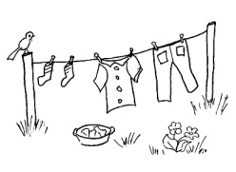
- Every day, she saves/saved a big sum of money.
- We are working/work in a project work, at the moment.
- She was dressing/dressed the jacket when the bell rang/was ringing.
- Did you go/Have you gone to the shopping centre, yesterday?
- Some weeks ago, he offered/offers me a pink bracelet.
- She was looking for/looks for a newspaper when her husband arrives/arrived.
- She hasn’t seen/doesn’t see her best friend since she travelled to London.
- I listen to/am listening to the radio every day.

- Rewrite the sentences using a passive structure

- She buys a lot of clothes. A lot of clothes __________________________
- They design their own clothes. Their own clothes _______________________
- She gave a baggy T-shirt. A baggy T-shirt __________________________
- You collected some shoes. Some shoes ____________________________

- I have spent a lot of money with my studies.
A lot of money ____________________________________________________
- He has created wonderful skirts.
Wonderful skirts _____________________________________________________
- She is painting her hair. Her hair ______________________________________
- They are reading a book. A book ________________________________
- You will buy some caps. Some caps _____________________________
- I will choose the striped T-shirt.
The striped T-shirt ____________________________________________________

- Circle the correct verb tense ( using the first or the second conditional)

- If I study hard, I will / would receive a new computer.
- If you don’t study more, you will/would fail your exams.
- Donna will buy a car if she passes/passed her driving test.
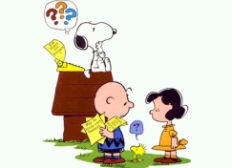
- If they don’t listen, they won’t/wouldn’t understand the instructions.
- If Mary trains/trained hard, she will finish the marathon.
- I would buy a horse if I had/have enough money.
- I wouldn’t/won’t buy a shirt if it was made in a sweat shop.
- I would lend her the money if I had/have a lot of money.
- If I won/win the lottery, I would live on a tropical island.
- If he drives so fast, he will/would have an accident.

