EXTENSIVE READING – Writing a book report

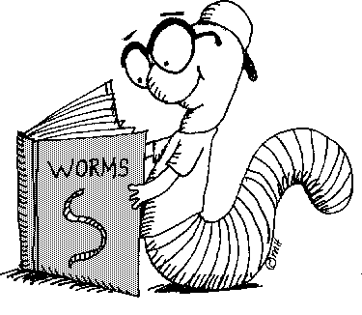

Choose one of the ideas and write your book report:

- Write a letter to the author. After reading a book, each student shares reactions to the book in a letter written to its author.
- Sell it! Each student pretends to be a publicist for the book that’s just been read. The student writes a speech that will persuade other students that they should read the book.
- Interview a character. Each student composes eight to ten questions to ask a main character in a book just completed. The student also writes the character’s answers to each question.
- Script it! Each student writes a movie script for a favourite scene in a book just read. At the top of the script, the student can assign real-life TV or film stars to play each role.
- Create a comic book. Each student can turn a book, or part of it, into a comic book, complete with comic-style illustrations and speech bubbles.
- Glossary and word search. Each student creates a glossary of ten or more words that are specific to a book’s tone, setting or characters, The student defines each word and writes a sentence from the book that includes that word. Then the student creates a word search puzzle that includes the glossary words.
- A new article. The student thinks about the story. What events from the story might appear in a newspaper? What may appear in the newspaper that is not directly in the story? The student writes the article.

The reports must include details that show the student has read the book.

