
 Agrupamento de Escolas da Quinta do Conde
Escola Básica Integrada da Quinta do Conde
Inglês
Name: No.: Class:

Name: Nº: Class:

- Do the following Lisbon quiz and find out more about the city.

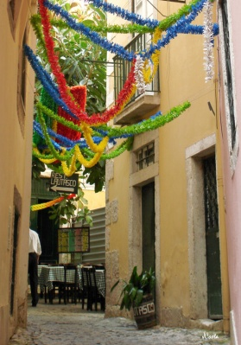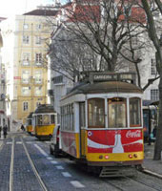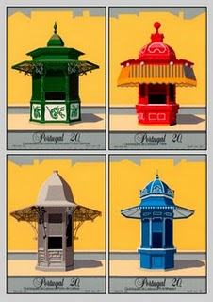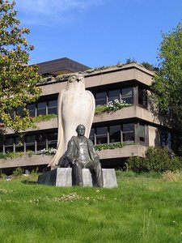
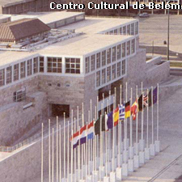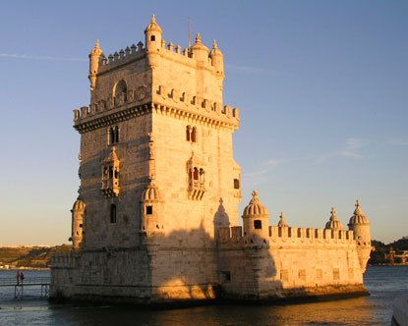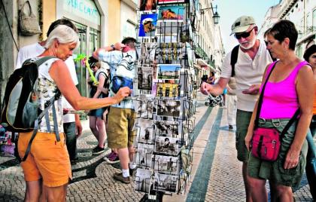

Lisbon quick quiz
A. Before answering the quiz, find out about the meaning of these words. Ask your classmates or your teacher for help.
hills: ____________________ sidewalk: ________________ lower: _______________
flat: ___________________ harbor: _________________ district: ________________
plague: _________________ earthquake: ______________ battle: _________________
river: ____________ left bank: _______________ tramway: _________________
bridge: _____________________

B. Answer this quiz about Lisbon. Then share your answers with your class.
1. Lisbon is composed of how many hills?
Five
Seven
Three
Nine
2. Lisbon is famous for its _________________ sidewalks.
Brick
Mosaic
Marble
Clay
3. The _________, Lower Town, in the flat area next to the harbor, is Lisbon's old business district.
Bairro Alto
Baixa
Chiado
Castelo

4. In November 1755, a(an) _____________ occurred killing an estimated 50,000 people and destroying most of Lisbon.
Plague
Fire
Earthquake
Battle
5. Lisbon is located on the ________ River.
Rio Grande
Tiber
Tagus
Arno

6. The medieval quarter in Lisbon is called the _________.
Bairro Alto
Castelo
Chiado
Alfama
7. Standing guard on the left bank of the river, in Lisbon, is a very large statue of ______________.
Manuel I
Dom Pedro IV
Marquês de Pombal
Jesus
8. The Ascensor of Santa Justa is a ___________.
Escalator
Funicular
Street Elevator/lift
Cable Tramway
9. Opened in 1966, the first bridge over the river in Lisbon was _________.
Ponte Vasco da Gama
Ponte Santa Caterina
Ponte Graca
Ponte 25 de Abril

- Web quest – Group work

- From what you know about Lisbon, discuss the main features of this city in terms of:

- Buildings
- Green areas (Parks)
- Museums
- Entertainment places

- Now, do the following web quest related to the city of London.

- Vocabulary – Individual work

- Look at the city map and label the pictures with the words in the box bellow.

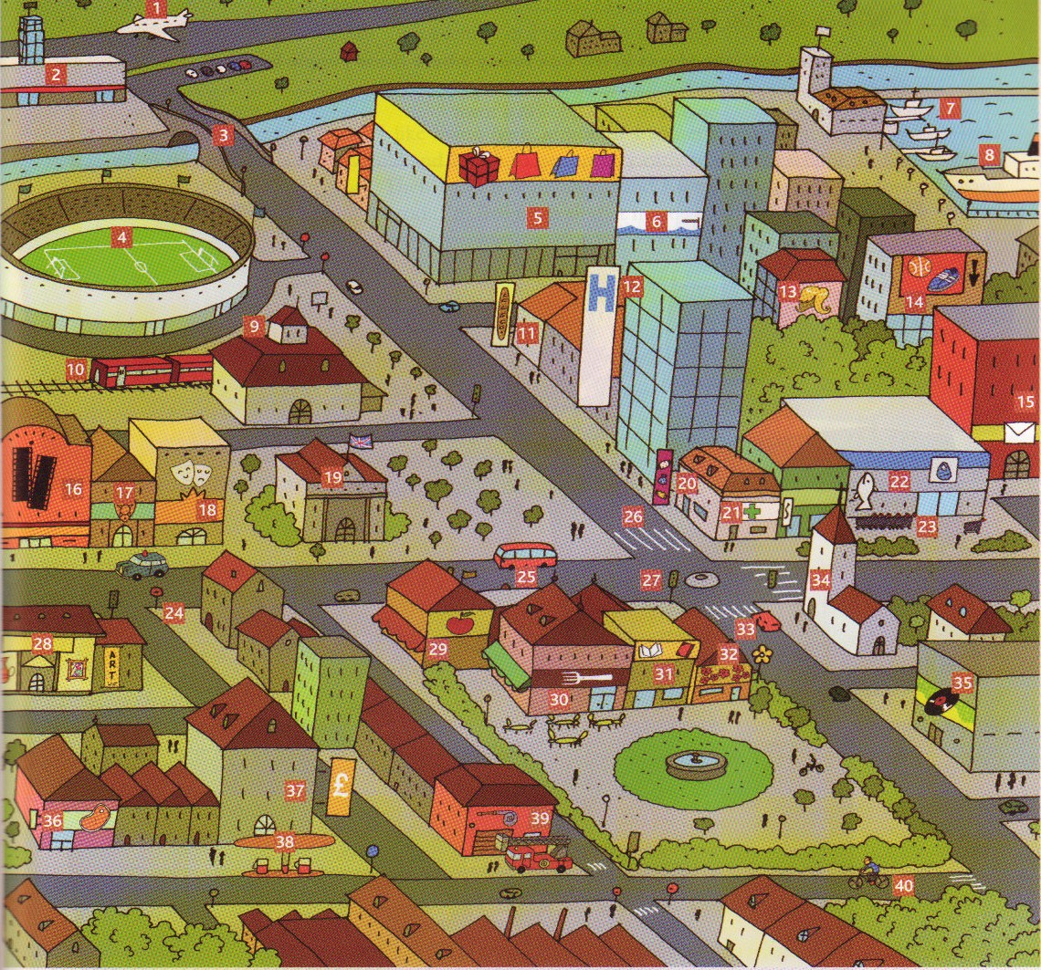
Travelling |  |  |  | Shopping |  |  |  | Facilities
car |  | airport |  | chemist’s |  | sports shop |  | Town Hall |  | theatre
bus |  | station |  | sweetshop |  | shopping centre |  | hospital |  | stadium
train |  | road sign |  | fishmonger’s |  | supermarket |  | church |  | fire station
plane |  | zebra crossing |  | butcher’s |  | book shop |  | post office |  | museum
ship |  | traffic lights |  | baker’s |  |  |  | police station |  | restaurant
boat |  |  |  | greengrocer’s |  |  |  | cinema |  | bank
bicycle |  |  |  | hairdresser’s |  |  |  | swimming-pool |  | Disco
bridge |  |  |  | florist’s |  |  |  | petrol station
3. Write the places.
a) It’s a place where doctors and nurses work ----------------------------------------------- a hospital
b) It’s a place where you can take a train --------------------- ---------------the s_______________
c) It’s a place It’s a shop where you can buy stamps and send letters --------- a p_________
d) It’s a place where you can watch films -------------------------------------- a c________________

- Order the letters to make places.

- WOTN ________________________
- HUCRCH _______________________
- OHPS _________________________
- TPEORL OASTTIN ________________
- USUMME ______________________
- THSMEISC ______________________
- GVLIALE _______________________
- APIORRT _______________________
- ERVRI _________________________
- RAPK __________________________

- Language – “Asking where places are” – Individual work

“Is there a bank near here?” Underline any mistakes in the sentences. If there isn't a mistake, tick the box.
a) The museum is next to the shop. It's on the right.
b) Go straight and turn the right.
c) It's between the station and between the park.
d) The chemist's is opposite to the school.
e) Excuse you me. Is there a bank near here?
f) Can you help me?
Parte inferior do formulário
Parte superior do formulário

- Look at the map and answer the questions.

a) Where’s the park? b) Where’s the Italian restaurant?
It’s on the corner of East Street. It’s __________ the bookshop.

c) Where’s the hotel? d) Where’s the museum?
It’s _________ the park. It’s ____________ the church.

e) Where’s the station? f) Where’s the supermarket
It’s ______________ of the petrol station. It’s ___________ the post office.

g) Where’s the post office? h) Where’s the church?
It’s _____________ the supermarket It’s __________ of Church Road.
and the cinema.

- Look at the map and complete the dialogues.

- A. Excuse me. Is there a bank near here?
B. Yes, there’s one in South Street, between the chemist’s and the bookshop.

- A. Excuse me. ___________ a chemist’s ____________________?
B. Yes, _________________ South Street, ____________________ the bank.

- A. Excuse me. ______________ a cinema ___________________?
B. Yes, _________________ Central Avenue, ___________________ the petrol station.

- A. Excuse me. ______________ a café ______________________?
B. Yes, _________________ South Street, ___________________ the post office.

- A. Excuse me. ______________ a bookshop ___________________?
B. Yes, _________________ South Street, ___________________ the Italian restaurant and the bank.

- A. Excuse me. ______________ a hotel___________________?
B. Yes, _________________ East Street, ___________________ the park.
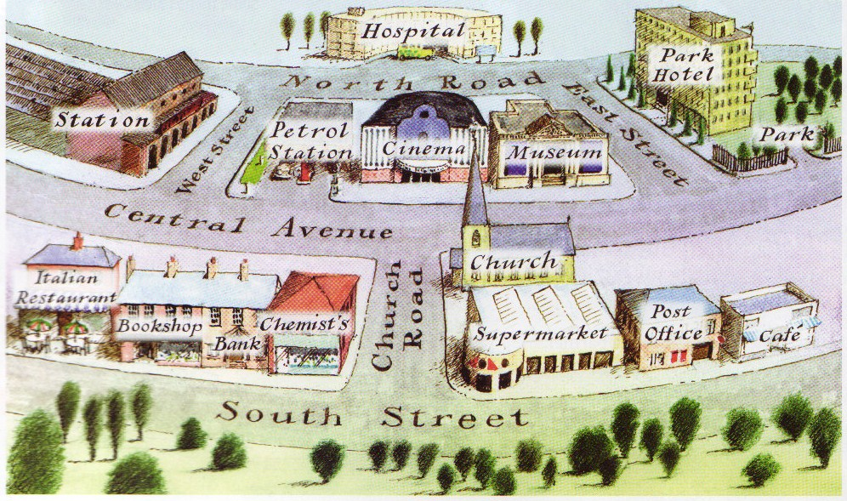
- Production – Pair work

- Look at the previous map again. A tourist is in front of the hotel and wants to know how to get to the supermarket, the station and the restaurant. Write the dialogues for the different situations.
Dialogue 1
A. Excuse me, could you tell me the way to the _______________?
B. ___________________________________________________________________________
_____________________________________________________________________________

Dialogue 2
A. Excuse me, could you tell me the way to the _______________?
B. ___________________________________________________________________________
_____________________________________________________________________________

Dialogue 3
A. Excuse me, could you tell me the way to the _______________?
B. ___________________________________________________________________________
_____________________________________________________________________________

Now, role-play the three dialogues in pairs.

II
- Vocabulary – Individual work
- Watch the following movie and pay attention to the type of language used.
YouTube - Let's Go Shopping! (English Lesson)
- Who says what? Read the following sentences and fill in the table.
. I hate this colour.  . Can I help you?  . These jeans don’t fit me.  . Can I try them on?  . The fitting room is over there.  . Where’s the fitting room?  . What size do you take?  . I can’t afford these jeans.  . I look terrible in these trousers  . It’s too dark for me.  . I take size 8.  . We’ve got a nice pair in the window. | . I’m afraid I haven’t any left.  . I haven’t got any larger sizes.  . How much does it cost?  . What can I do for you?  . Look at these shirts.  . How much is it?  . What size are you?  . Can I pay by credit card?  . Yes, I’d like a pair of jeans.  . That’s 20 pounds.  . Thank you very much and have a nice day.  . Here’s your change.

Shop-assistant |  | Customer
Offering help |  | Accepting help
Asking about size |  | Answering about size
Giving information (price/sizes…) |  | Asking to try something
Saying goodbye |  | Commenting on something (colour/size/price…)
Saying goodbye |  | Asking about price/payment

B. Language – “Quantifiers – some, any and no” – Individual work

- Rita’s mother is going shopping. Complete her conversation with Rita using some, any or no.
Mother: I must go to the supermarket. There’s __________ butter, ________eggs and
_______ beer.

Rita: Don’t forget to buy ________ bread, water and potatoes, too. There’s almost nothing left. Thank God there’s _______ milk.
Mother: Oh dear! I also need _________ meat. Do we need __________ bottles of wine?
Rita: No, there are still ___________.
Mother: Is there anything else we need?
Rita: No, I think that’s it.
Mother: Why don’t you come with me? I need __________ help to carry everything.
Rita: OK. But can we go to the new boutique as well? Please!!! I saw some fabulous jeans in the window…
- Fill in the blanks with some, any or no.

- There are _________ potatoes in the basket.
- Is there ________ milk in the fridge?
- There are ________ apples but _________ pears.
- There aren’t __________ chocolates.

- Production – Pair work

- The Harrods is one of the most known English department stores. Visit it and find out:
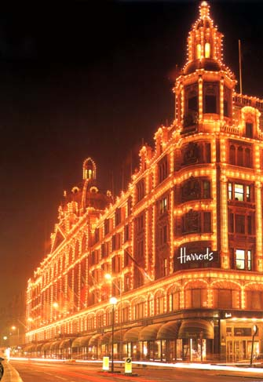

- Harrods location in London.
- Some luxury brands you can find there.
- Harrods’ next event

Harrods - Visit the store

- Imagine you are at Harrods’ supermarket. One of you is the shop assistant and the other is the customer. Write the dialogue in your notebook.
Shop assistant
1. Greets and offers help.
3. Asks the quantity.
5. Gives the product and comments on their quality.
7. Tells the price.
9. Says there’s no more left.
11. Accepts.
13. Thanks.
15. Says goodbye
Customer

2. Greets. Asks for some products.
4. Answers.
6. Asks for the price.
8. Asks for something else.
10. Comments. Asks for payment with credit card.
12. Pays.
14. Says goodbye.

- Finally, do the “Shopping game” to role-play conversations in a shop.

Web quests
GROUP ONE. Map (if necessary)
Arthur is from London. What do you know about his city? Not much? Click on the internet links to complete the document about Arthur’s favourite places. When you have finished, be ready to speak about your places to the other groups.
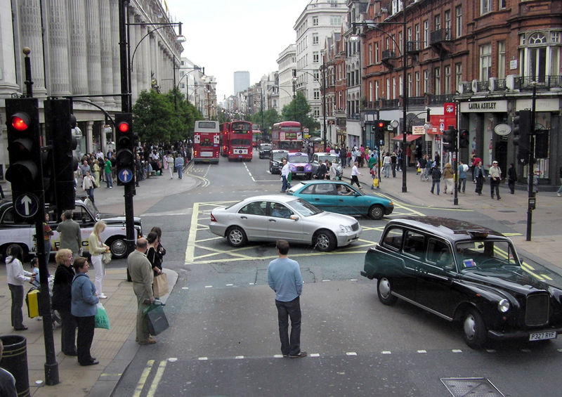

“I live north of Oxford Street,
not far from Madame Tussaud’s and
Sherlock Holmes Museum.* ”

* from Spring 4e, page 12 / 13, Ed. Hachette.
Images from Wikipedia

- Oxford Street is ...

a famous street in London with many shops. a street in Oxford with many shops.

the name of a shop.
- It is very easy to get there. There are…

5 underground stations. 3 underground stations. 4 underground stations.
- Name them:
____________________________________________________________________________
- Where is it on your London map?
____________________________________________________________________________

- Madame Tussaud’s is

the name of the Queen’s maid. a wax museum. the name of the King’s wife.
- She was born in ...
London. Paris. Strasbourg.

- She was born in…

1761. 1671. 1567.

- It is located at…
____________________________________________________________________________
- Where is it on your map?
_____________________________________________________________________________
- The Tube / underground station to go there is…
_____________________________________________________________________________

- The Sherlock Holmes Museum opens at ______________________and closes at_______________________

- It is open on Christmas day:
right wrong

- To visit it a child must pay ______________ and an adult _______________.

- Its address is…
_____________________________________________________________________________
- Sherlock Holmes is not a real detective. He was created by...

Sir Arthur Conan Doyle. Emily Bronte. J.K. Rowlings.
- The story says he lived in this house with his friend,

Dr Moriarty. Dr Quinn. Dr Watson.
- He lived in this house...

from 1865 to 1856. from 1881 to 1904. from 1984 to 1998.
g)Sherlock was born on…

7th January 1855 6th January 1854 8th January 1854.
h)Name a famous Sherlock story
___________________________________________________________________________
i)Where is it on your map?
___________________________________________________________________________

GROUP TWO. Map (if necessary)
Arthur is from London. What do you know about his city? Not much? Click on the internet links to complete the document about Arthur’s favourite places. When you have finished, be ready to speak about your places to the other groups.
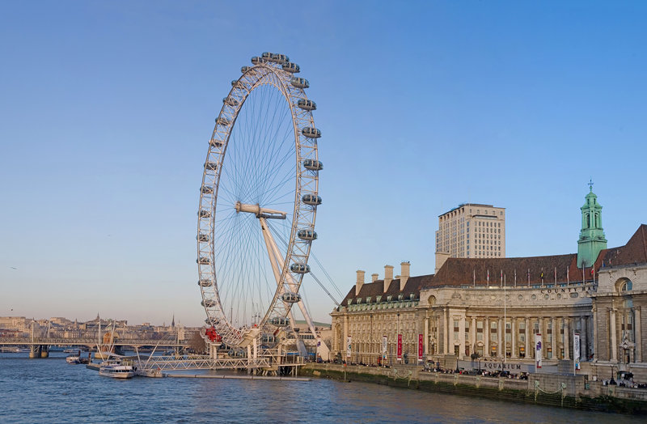
« The London Eye is between the South Bank Arts centre and Westminster Bridge. I love going on it. My dad works nearby. »

* from Spring 4e, page 12 / 13, Ed. Hachette. Images from Wikipedia

1. The London Eye is…

a TV camera filming London. the name of the police in London.

an observation wheel.
- It is…

135 metres high. 115 metres high. 35 meters high.
- The telephone number is…
____________________________________________________________________
- The maximum number of visitors in one hour is...

150. 1200. 1500.
- It is open from.............. to ……………………… or ………………………………………………………

- Its address is…
_____________________________________________________________________________
(check the “find us” section to get that information)
- The tube / underground station to go there is…
_____________________________________________________________________________
- Where is it on your London map?
_____________________________________________________________________________

2. Westminster Bridge opened in…

1850 1862 1950
- They started its construction in…

1845 1739 1839
- It is painted in...

blue yellow green
- It is not very far away from…

Victoria Station Montparnasse Station Waterloo Station.
- It is made out of…

stone iron plastic

- If you want to go there by underground, get off at…
___________________________________________________________________________
- Why is it famous?
___________________________________________________________________________
- Where is it on your map?
___________________________________________________________________________
GROUP THREE. Map (if necessary)
Arthur is from London. What do you know about his city? Not much? Click on the internet links to complete the document about Arthur’s favourite places. When you have finished, be ready to speak about your places to the other groups.
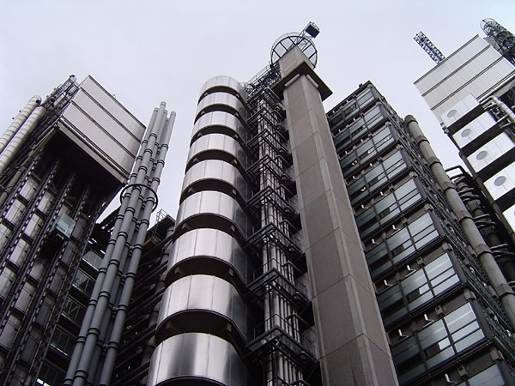
« This is my favourite skyscraper. It is in the City, not far from the Tower of London. Mum is working near it at the moment. »
* from Spring 4e, page 12 / 13, Ed. Hachette. Images from Wikipedia
- Arthur’s favourite skyscraper is…
______________________________________________________________
- It is…

195 metres high 98 metres high 95 metres high.

- It was finished in…

1886 1986 1996
- Its architect is…
____________________________________________________________________________
- It resembles a Building in Paris, can you name it?
____________________________________________________________________________
- What is the origin of the building’s name?
_____________________________________________________________________________ _____________________________________________________________________________

- In which Borough of London is it?

The City Westminster Bankside

- Where is it on your London map?
_____________________________________________________________________________

- The Tower of London was constructed by…

Queen Elizabeth I William the Conqueror
Sir Norman Foster.

- Where was William from?

England Italy Germany France.
- William had other nicknames. In France, we call him…
_____________________________________________________________________________
- The Tower of London was…

a shopping centre a military fortress a church.
- Its original mission was to…
_____________________________________________________________________________
- But it was also…
_____________________________________________________________________________
- To build it, people used…

iron stones from France plastic
- Where is it on your London map?
_____________________________________________________________________________

Shopping game
Worksheet A: Shopping lists
List 1

Here are the things you need to buy
- a blank CD to burn some music on your laptop
- a newspaper, preferably ‘The Guardian’ or ‘The Independent’
- Some low-fat milk
- Half a kilo of nectarines
- A monolingual dictionary, English – English, but small enough for your pocket
You also need to change a 10 pound note for 10 one pound coins

List 2

Here are the things you need to buy
- An extension lead for your MP3 player
- This week’s ‘Film Review’ magazine
- Some wholemeal bread
- Some bananas, but the ones used for cooking
- A good grammar practice book for your level
You also need to find out what time it is, as you have lost your watch

List 3

Here are the things you need to buy
- Some high quality paper for your printer
- Some chewing gum, strawberry flavour
- A couple of packets of instant noodles – you like them spicy
- A kilo of oranges
- A good guide to grammar in English
You also need to know where the nearest bank is

List 4
Here are the things you need to buy
- Some headphones for your computer so you can use the internet to make
telephone calls
- A book of first class stamps, preferably 10.
- Four mangos, not quite ripe would be best
- Some black pepper corns for your pepper mill
- A bi-lingual dictionary, English – your language
You also want to put a card in the window of a shop saying that you are looking for a
private teacher to help with your English

List 5

Here are the things you need to buy
- Some unsalted butter
- A black pen that you can use to write on CDs
- a telephone card to make international calls
- half a kilo of apples. You like them red and sweet
- a dictionary of phrasal verbs
You also want to know if there is somewhere to post your letters nearby

Worksheet B: Shopkeepers
List 1
You have a computer shop. You have the following in stock:
- Blank CDs to burn music – these are on special offer
- You are out of stock of extension leads for MP3 players
- Paper for printers – you have low, medium and high quality, but the high quality
is very expensive
- Headphones for computers – you have them with a microphone or without
- Pens that you can use to write on CDs – you have blue and red only
You don’t let people put cards in your window and don’t know what time it is, or where
the nearest bank is. You do know where the nearest post office is, and you have change for 10 pounds.

List 2
You have a newsagent’s. You have the following in stock:
- Newspapers. You only have the ‘Independent’, the ‘Sun’ and the ‘Mirror’
- ‘Film Review’ magazine. This week if people pay extra they can get the special
guide to summer films also
- Chewing gum. You have peppermint, cherry and banana.
- Stamps. You have first and second class, in books of 10 and 20.Some
wholemeal bread
- Telephone cards to make international calls, at different values
You let people put cards in your window but don’t know what time it is, or where the
nearest bank or post office is. You have no change.

List 3
You have a bookshop specialising in learning languages. You have the following in
stock:
- Bilingual dictionaries for English and Spanish, French, Chinese and Arabic.
- Guides to English grammar for intermediate levels and below
- Vocabulary practice books, but no grammar practice books at the moment
- Special dictionaries for idioms and also for phrasal verbs
- Monolingual dictionaries, English-English, for all levels but only large size
editions
You don’t let people put cards in your window and don’t know what time it is, but you do
know where the nearest bank is. You have no change.

List 4
You have a shop selling fruit and vegetables. You have the following in stock:
- Mangos, ripe and ready to eat today
- Oranges
- Bananas, for both dessert and cooking
- Peaches, which you are trying to get people to buy instead of nectarines
- Apples, green and crispy
You don’t let people put cards in your window and don’t know where the nearest bank of
post office is. You have no change but do know what the time is.

List 5
You have a small supermarket. You have the following in stock:
- Salted butter
- Instant noodles, in pots and packets, but only spicy ones
- Full-fat and low-fat milk
- Black pepper, in powder and as corns
- White bread
You let people put cards in your window but don’t know what time it is, or where the
nearest banks or post offices are. You have change for 10 pounds.

A shopping role play – Try - Activities © BBC | British Council 2006
www.teachingenglish.org.uk

